**Instructions on Running and Editing the Python Dashboard for Apple Watch Sensory Information**

**Using the Flask Server on the AWS instance**

1. Connect to the AWS instance:
   1. Open your web browser and navigate to https://aws.amazon.com/console/
   2. Click “sign in to the console”
   3. Login with the IAM user information provided to you
   4. Click on “Services” at the top left corner and find the service “EC2”
   5. Click on “instances” on the left navigation bar
   6. Check the AppleWatchDashboard box and choose the “connect” at the top
   7. Choose the EC2 Instance Connection option and click “Connect”

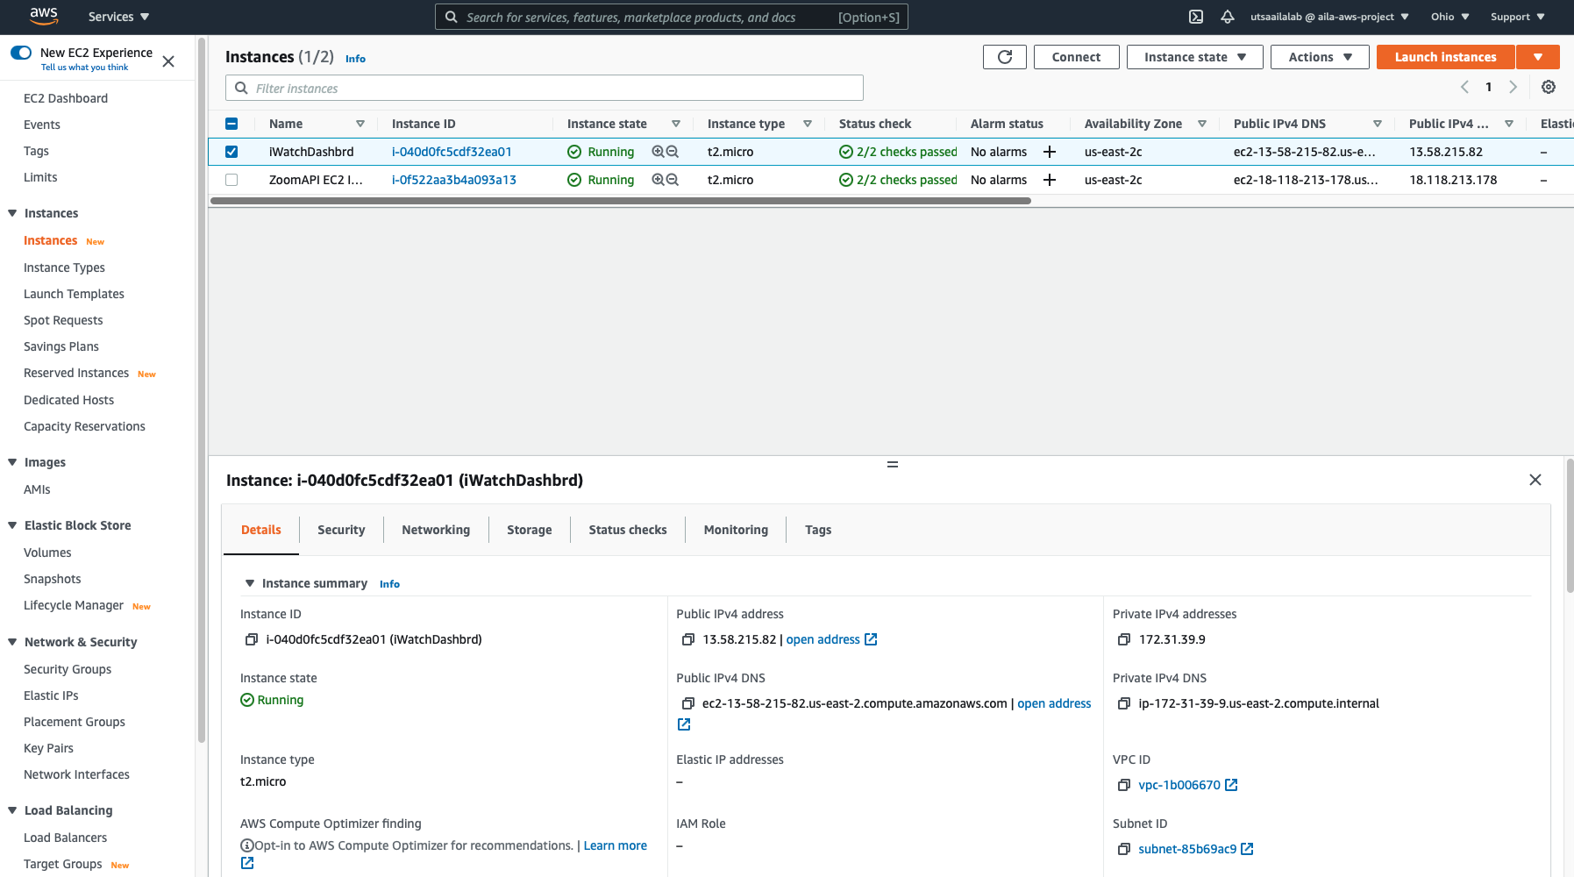

1. Run the python dashboard server:
   1. While in the terminal navigate to the directory that holds the python dashboard file by running this command: cd NathanM_Dashboard_app/Dashboard_app
   2. At the time of writing these instructions the file is located in this directory
   3. To run the server, run the python file with with command: python3 NewDashboard.py
   4. Wait for the webserver to fully start
2. View the dashboard by navigating to the list of instances webpage you visited earlier (in the image above). Click on the instance ID of the apple watch dashboard. 
3. Copy the Public IPv4 address of the instance and enter it in the web browser along with the port number “8005” and navigate to that IP. Your URL should look like: “13.58.215.82:8005”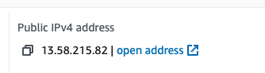

**Editing the python dashboard file:**

**Note: This can be done with VIM, my preferred method is visual studio code**

1. Download Visual Studio Code
2. Inside of Visual Studio Code navigate to the extensions tab and search “ssh”. Install this extension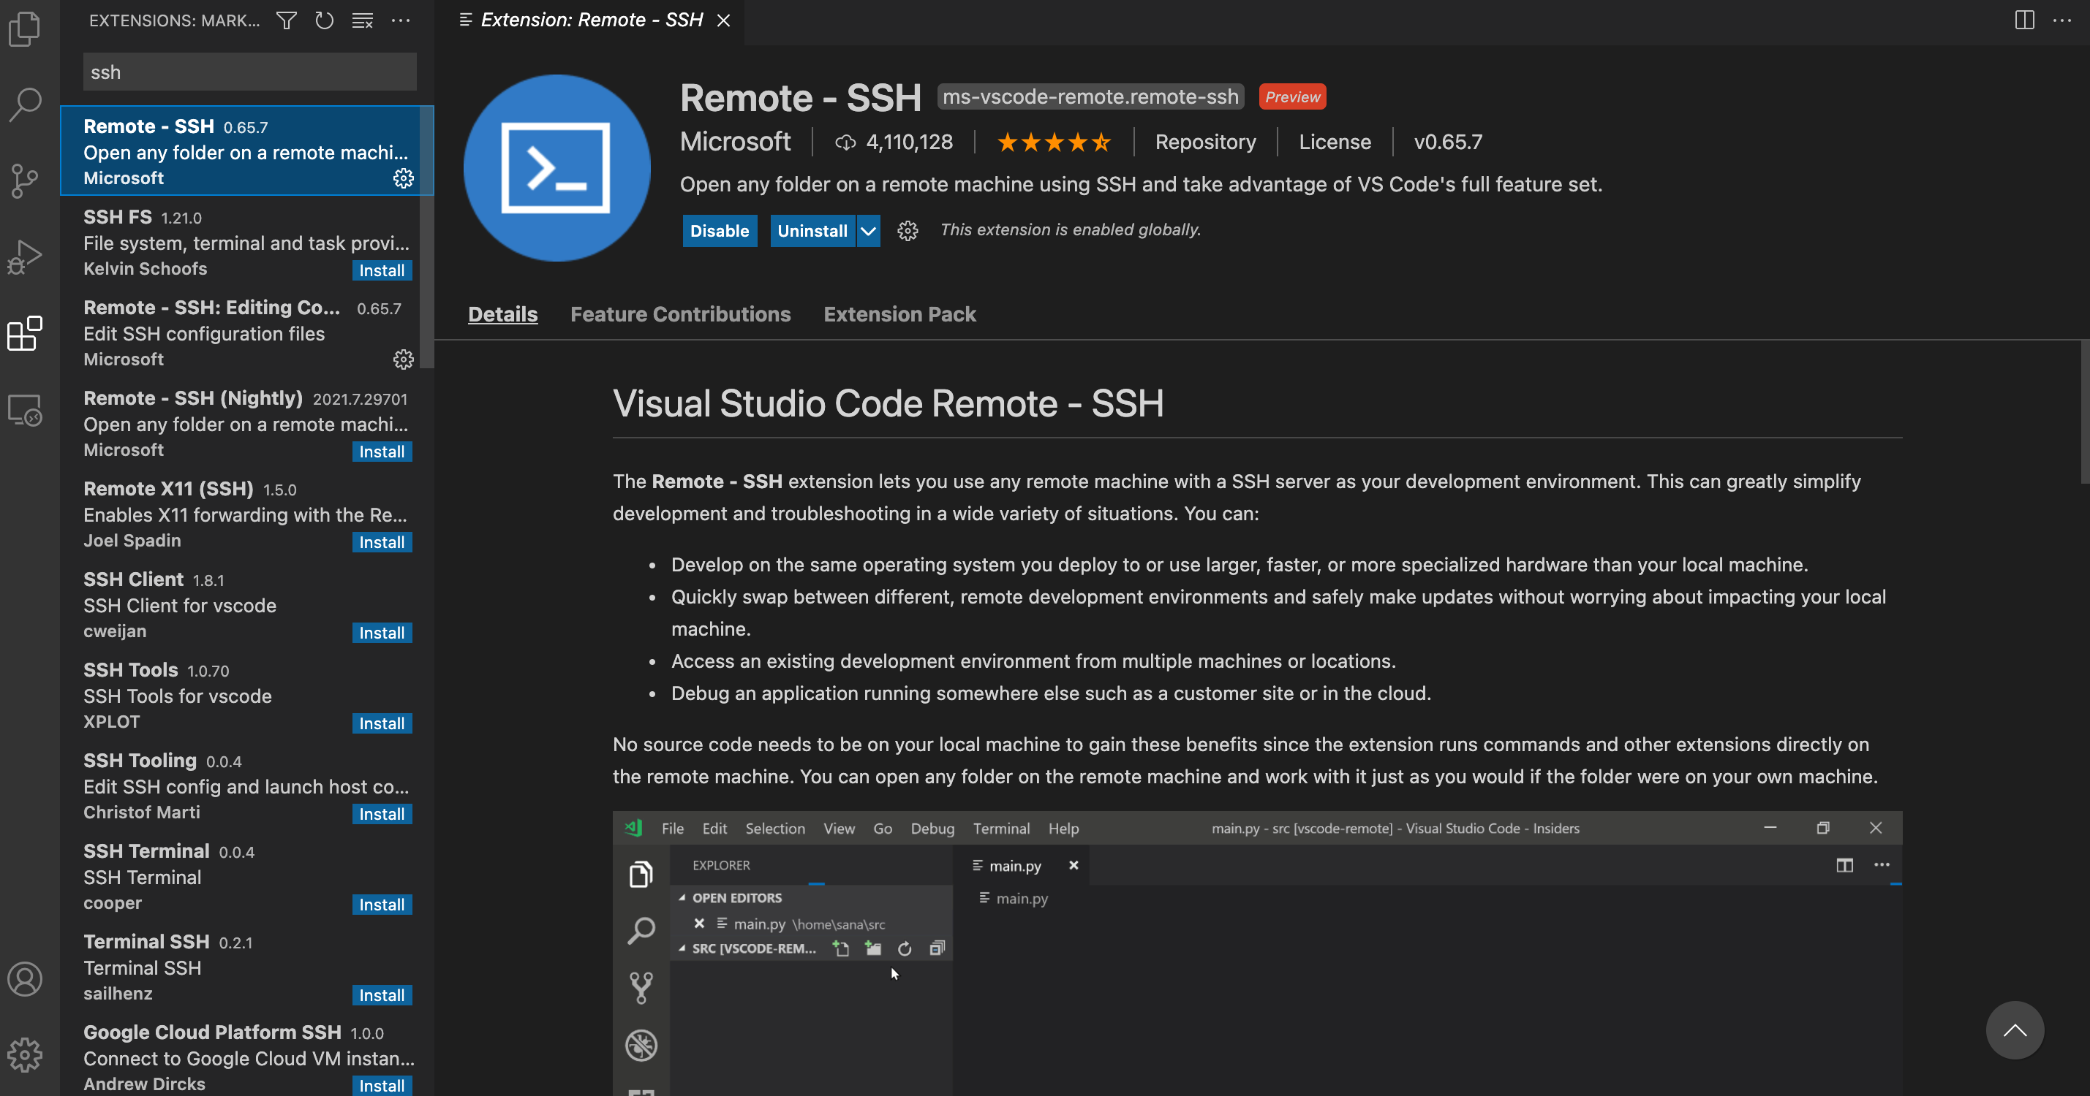
3. Navigate to the remove explorer tab and click the “+” to add a new remote host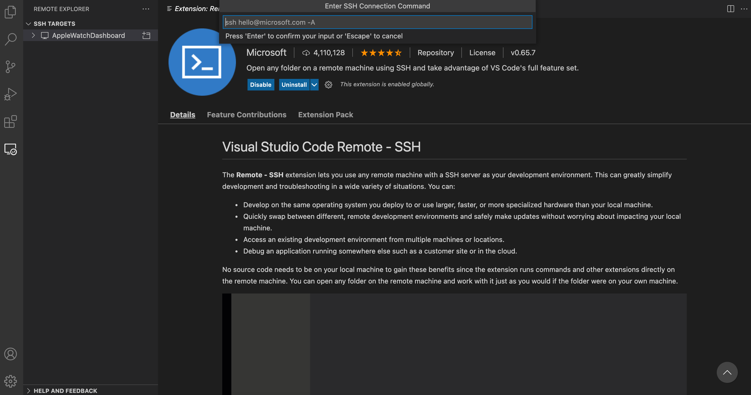
4. Navigate to the instance list in the web browser choose the connection option. Steps 1.e - 1.g in the above instructions.
5. Choose the “ssh client” option
6. Copy the example option on the page but remove the -i "AppleWatchDashboard.pem" from the command. 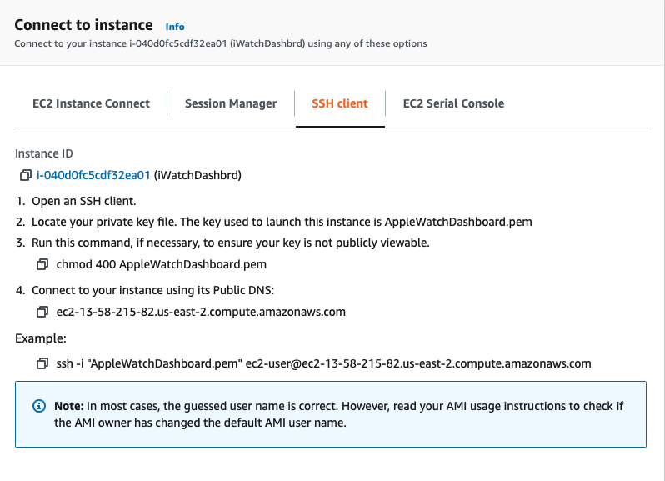
7. Paste that command in the “enter ssh connection command” text box in visual studio code. 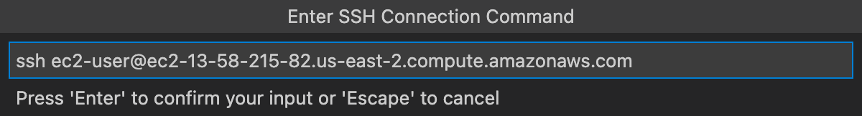
8. Hit enter twice and you should now see the new host connection in the list of ssh targets
9. Click the gear and hit enter to edit the ssh configuration file
10. Add a new line under “User” with “IdentityFile” followed by the path to the Apple Watch ssh key.
    1. This ssh key must be provided to you by someone who has worked on this instance before

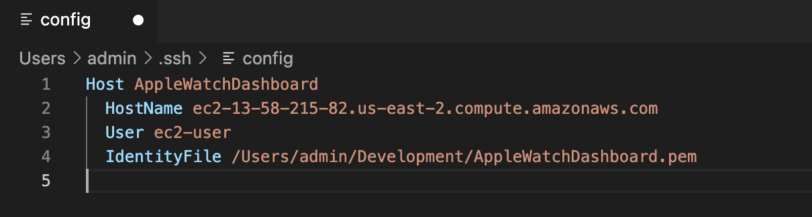

1. Save the file with command + s
2. Right click your ssh target in the list and choose “connect to host in current window”
3. Click on the explorer tab and choose “open a folder”
4. Navigate to the folder that contains the python dashboard file and choose “ok”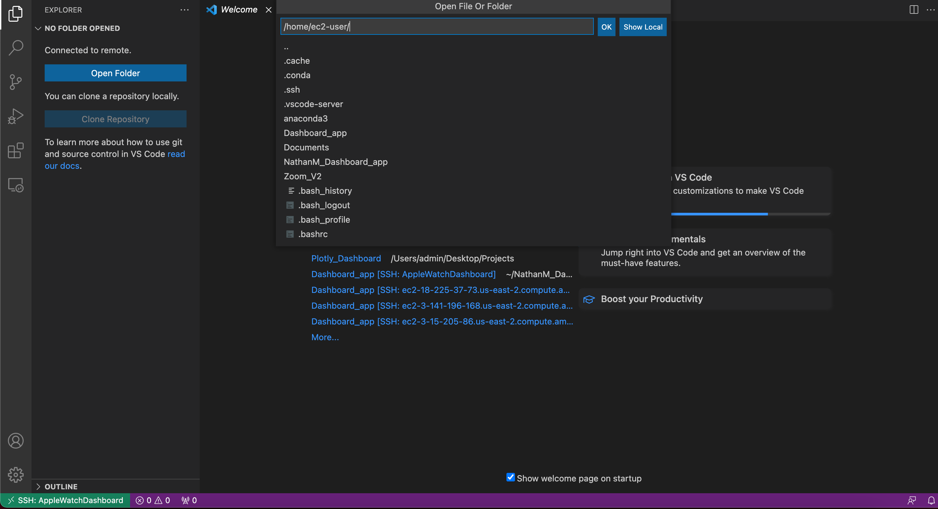
5. You can now edit the python file. Command + s will save the file and you can run it using the instructions above.

**Editing the python dashboard file using VIM:**

1. Follow steps 1 – 2.a to open a terminal connection to the AWS instance and navigate to the dashboard python file.
2. If the file name has changed replace NewDashboard.py with the new filename. Run the following command: vim NewDashboard.py 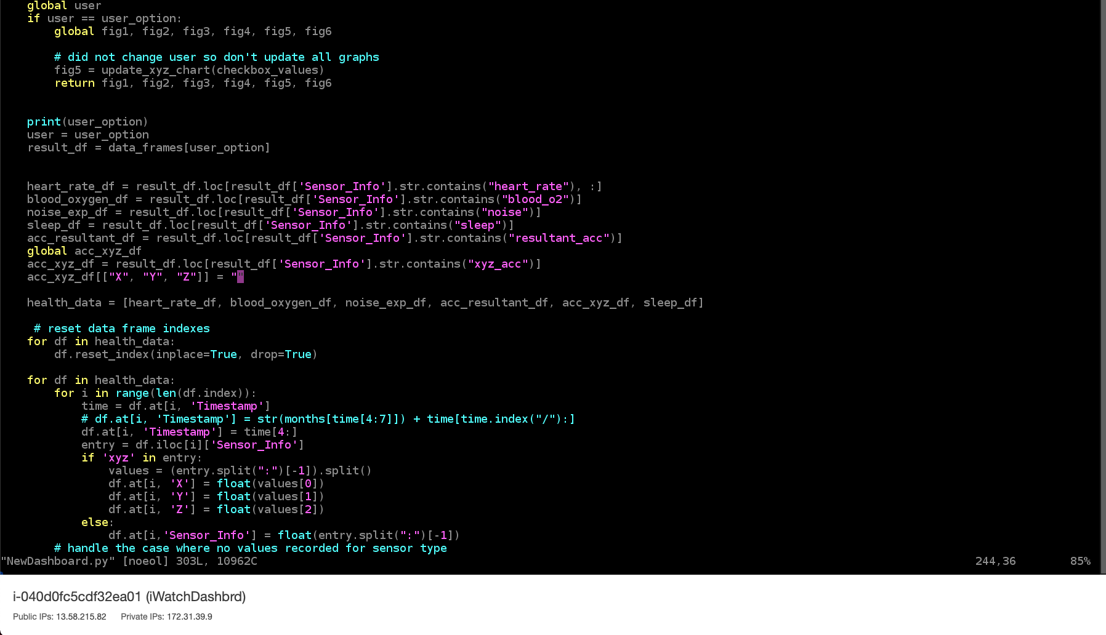
3. You can move up and down the file with the arrow keys. Hit “I” on your keyboard to edit the file and escape to stop editing
4. To save your changes and exit the VIM editor type the following: “:wq”
5. To exit the VIM editor without saving type the following: “:q!”

**Notes:**

If you connect to the instance using Visual Studio Code, close your connection before running the server. This is because visual studio code’s ssh connection requires a lot of memory from the instance. It is generally a good idea to download the file and edit the file locally on your computer. Also running it locally.

If the instance is not responding to ssh requests, it is likely frozen. You must stop the instance and start it again to reboot it. Keep in mind that once you stop and start the instance again, it’s public IP changes and the ssh host also changes. Follow the steps above to get the new public IP and ssh command.

To connect using ssh in visual studio code, you must have the ssh access key file. This file can be provided to you by someone who has developed on this machine before.